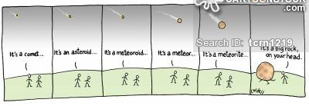
Astronomy- Unit 1 –
Comets, Meteors, Asteroids

COMETs
- Small body of ________, rock and cosmic dust.
- “Dirty _________________ “
- Tail is able to be seen when comet gets close to the __________ (points ________ from the sun due to solar ___________)
- Gets ______________ with every trip (it MELTS)
- You can see a comet for ___________ (or even months) … unlike a meteor!
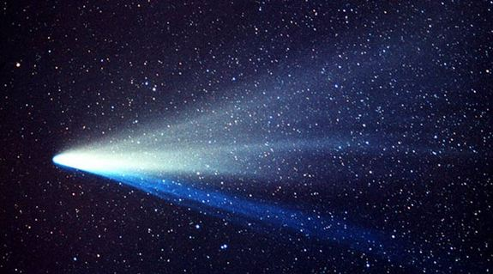

ASTEROIDS
- __________ rocky bodies that orbit the ________ (over 100,000 known)
- Most are ____________________ shaped (not round)
- Most are found in the _________________ _____________ (between MARS and JUPITER)
- _____________ is the largest known asteroid (now considered a dwarf planet)
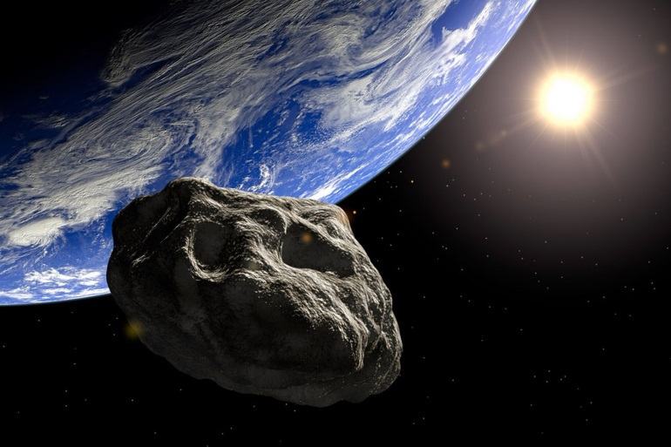

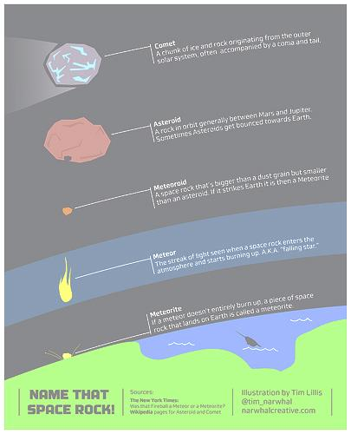
ME-TEO…. What?
Meteoroid: _____________ pieces of comets or asteroids in _________________

Meteor: burning up in the ______________________
(inaccurate to say “falling/shooting star”)

Meteorite: hits the __________________ (MAY make a ______________)

PREVIEW QUESTION
- What are the 8 phases of the moon?

