Astronomy- Unit 1 –
Galaxies and Milky Way Notes
Quick Questions:
What is the difference between inertia and gravity? | What is the cause of the seasons? | What is the difference between the Earth’s orbit (revolution) and it’s rotation?

GAlAxy
Galaxy: A large group of ________________ , ___________________, and millions of ______________ .
3 Main Shapes:

_____________________ __________________________ ______________________
Most galaxies Older Stars Younger
Looks like:

Our Home is the only way! The Milky Way that is….
A Light Year refers to ______________________________ (light travels 6 trillion miles in __________ year)
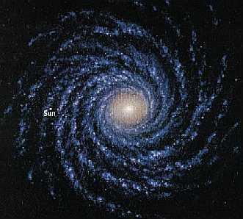
The Milky Way is ________________________ light years wide and ___________________________ light years thick
WE ARE _____________________________ light years from the center.
We are located on a ________________________ of the Milky Way
(Fun Fact: If every star in the Milky way was a grain of salt, they would fill an Olympic sized swimming pool.)
Galaxies exist in groups called __________________________.
We have _________________ galaxies in our cluster called the Local Group.
The Milky way is the ___________________ largest galaxy in this group (Andromeda is the largest).
Ending Question:
Put the following in order from smallest to largest: Milky Way Galaxy, Universe, Earth, Solar System, You

